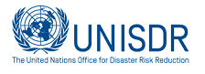

WORKSHOP REPORT
2016 Korea-Japan-China
Trilateral Cooperation Workshop for Public Officials
June 2-3 in PyeongChang, GangWon-Province, Republic of Korea
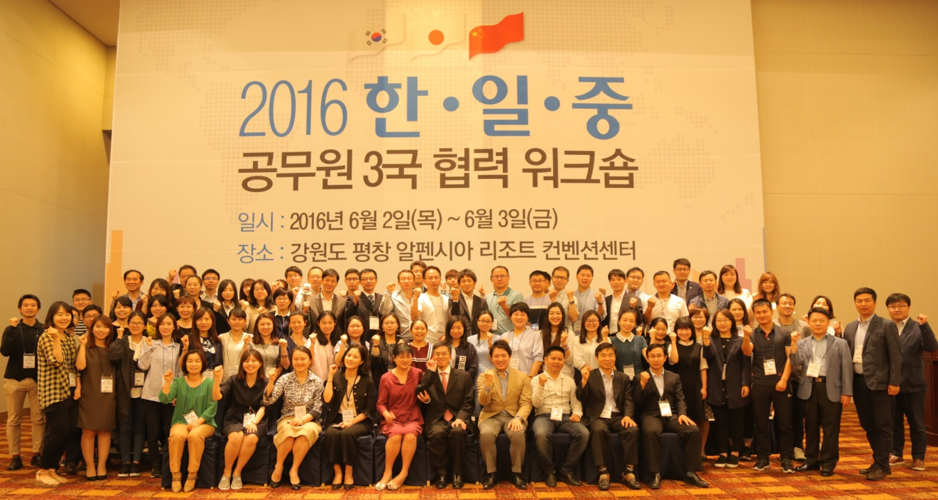
The Ministry of Foreign Affairs of the Republic of Korea held the Trilateral Cooperation Workshop for Public Officials among Korea, Japan and China with the aim of deepening understanding of trilateral cooperation, exploring measures for the further development of cooperation at the local government level among the three countries, and seeking to build networks among participants.
Korean local government officials in charge of international cooperation and central government officials in charge of trilateral cooperation among Korea, Japan and China, including Japanese and Chinese public officials who are working or studying in Korea, participated in the event.
Representatives of UNISDR ONEA-GETI presented on the importance of Disaster Risk Reduction in the area of Northeast Asia and implementing the Sendai Framework to achieve 17 Sustainable Development Goals.
The Sendai Framework for Disaster Risk Reduction (2015-2030) is an international policy framework which was adopted by UN Member States on 18 March 2015 at the Third UN World Conference on Disaster Risk Reduction in Sendai City, Miyagi Prefecture, Japan.
The framework outlines seven global targets to be achieved over the next 15 years: a substantial reduction in global disaster mortality; a substantial reduction in numbers of affected people; a reduction in economic losses in relation to global GDP; substantial reduction in disaster damage to critical infrastructure and disruption of basic services, including health and education facilities; an increase in the number of countries with national and local disaster risk reduction strategies by 2020; enhanced international cooperation; and increased access to multi-hazard early warning systems and disaster risk information and assessments.
At the WCDRR in Sendai, UN Secretary-General Ban Ki-moon said:
“This is the first stop on our journey to a new future…To put the people of this world on a sustainable path. Disaster risk reduction advances progress on sustainable development and climate change.”
2015 was a landmark year for international agreements on sustainable development: beginning in March 2015, UN Member states adopted the Sendai Framework for Disaster Risk Reduction 2015-2030, then in June 2015 the Addis Agreement on Financing for Development, in September 2015 the Transforming our world: the 2030 Agenda for Sustainable Development and its 17 SDGs and in December, the Paris Agreement on Climate Change. The mutually reinforcing agreements recognized that disaster risk must be reduced to achieve sustainable development and adaptation to climate change. During the workshop, the importance of understanding and assessing risk was highlighted as key to developing and implementing risk-informed policies and plans for sustainable development.

Outcomes
Participants became familiar with the Sendai Framework for Disaster Risk Reduction, its goal, targets and priorities with the context of the SDGs. Participants were also introduced to UNISDR tools and resources to help understand risk, such as the Global Assessment Report on Disaster Risk Reduction and the Making Cities Resilient global campaign.

